 | Expression of Interest (EOI)
Goods Offered: | Starting Barriers
EOI Issue Date: | April 2020

Part 1 - Expression of Interest (EOI)

Closing date and time | All submissions to be considered as part of this EOI are to be lodged by 5pm Tasmanian time on Wednesday April 30th 2020 Tasracing reserves the right to extend the closing date and time.
Pre-quotation briefing session details: | Tasracing does not intend to hold a formal briefing/inspection session for these goods.
Lodgement | A expressions of interest must be lodged as follows: Ricky Aitken: email r.aitken@tasracing.com.au
Contacts | Ricky Aitken: email r.aitken@tasracing.com.au Phone: 0447 212 970
Notification of outcome | Tasracing anticipates that successful parties will be notified in writing of the outcome of this EOI by 5pm May 4th 2020  Unsuccessful EOI submissions will be notified at the end of the procurement process.
Information to be provided in the submission as part of this EOI  Terms and Conditions | - Company name or name of individual(s)  - All submissions must be supplied in legible English or they will be discarded  Acceptance of the EOI is subject to the purchaser agreeing to be bound by the Terms and Conditions, a copy of which will be supplied to each potential purchaser.
Evaluation criteria | In the EOI evaluation process, Tasracing will take into consideration all relevant factors, including:  - Compliance with the Conditions of the Expression of Interest  - Price  Tasracing will not be bound to accept any expression of Interest.
Status of quotation | An EOI lodged by a prospective party or individual in response constitutes an offer by the prospective party or individual to purchase the Goods set out in this EOI.  The acceptance of the EOI by Tasracing, in accordance with the terms included within this EOI, will result in a legally binding contract for the purchase of the Goods with the respective party or individual.

Part 2 – Overview of the Goods for offer

Goods to be supplied: | The following goods (the Goods) are to be offered:  - 1 x 4 Used Stall Thoroughbred Starting Barriers located at the Spreyton Thoroughbred Racing Track as per the following;  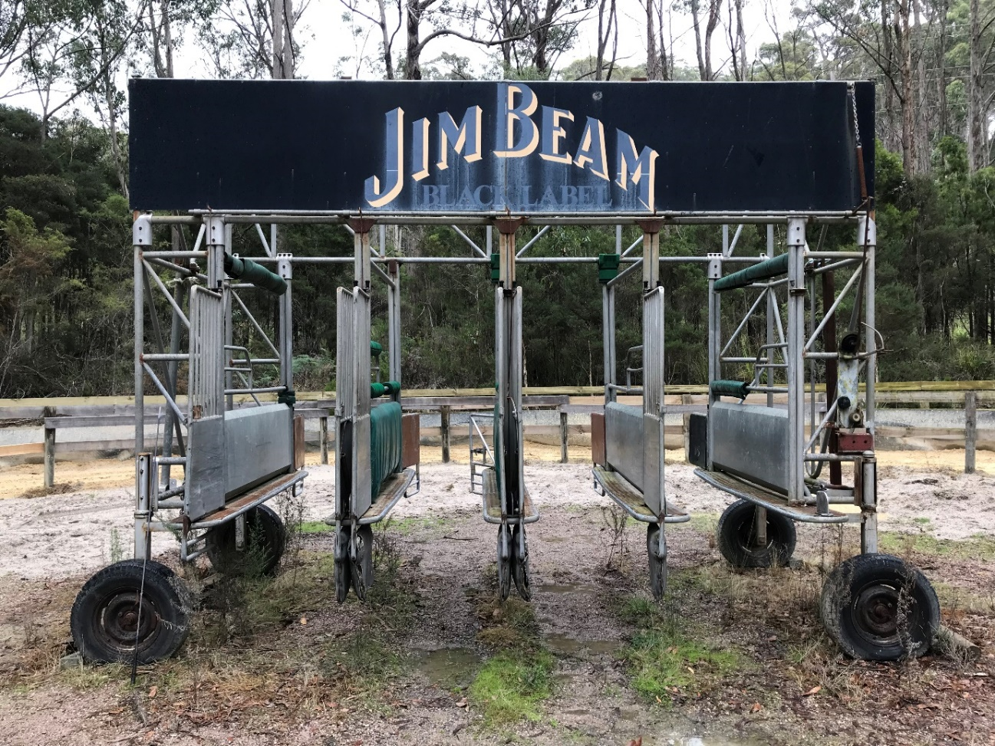
Timing of the Supply of the goods | The Goods are supplied by Tasracing on a as is where is basis with successful purchaser(s) arranging to carry out all associated works required for the removal of the goods from Tasracing property, including to undertake any remedial works and activities for any damage that is incurred by Tasracing during this process. The successful purchaser(s) will be required to book a time with Tasracing to facilitate the collection and removal of the goods.  The goods will not be the responsibility of Tasracing once payment has been confirmed.  Tasracing will not be liable for any loss or damage caused by the goods once possession of the goods has occurred.
Payment of the EOI sum | The accepted EOI sum is payable and confirmed by Tasracing before any permission is granted to obtain the goods from the Tasracing site as follows:  Payment to be confirmed by Tasracing before obtaining the Goods

Expression of Interest Form

To be completed by the Purchaser

Important Note: This expression of interest form must not be separated from this EOI. If lodging an expression of interest, you must lodge this EOI in its entirety.

To: Tasracing Pty Ltd
I/We:
the Purchaser
(insert name, USE BLOCK LETTERS)
(insert ACN or ABN)
hereby offer to purchase Tasracing Pty Ltd (Tasracing) Goods specified in this EOI in accordance with the Conditions of this EOI and the following Agenda issued by Tasracing:

Lump Sum:
The price offered is:

$ | excluding GST
(insert offered price)

The personnel (if any) specified in Table 1 will procure the Goods if this Expression of Interest is accepted:

Table 1
Name: | Position: | Goods Being Purchased

The Purchasers details for the Goods will be as follows:

Table 2

Address:
Email Address or Facsimile:
Contact person:

I/We declare that:

(a) the Conditions of the Expression of Interest are agreed;
(b) the information in this EOI is agreed and;
(c) the information and particulars provided as part of this offer are accurate and correct.
Dated:
(insert date)

Signing by a Purchaser who is an individual
Signed by the Purchaser in the presence of the witness named below:

Purchaser’s signature:  → |  | Witness  signature:  →
 | *Witness print name:
*Witness print address:

*Use BLOCK LETTERS.

Signing by a Purchaser that is a Company
Signed for and on behalf of the Purchaser under section 127(1) of the Corporations Act 2001 (Cwlth):

Signature:  → |  | Signature:  →
*Print  name and office  held: |  | *Print  name and office  held:
*Use BLOCK LETTERS.

Signing by a Purchaser that is in a partnership
Signed for and on behalf of the Purchaser (a partnership) by the partner named below who, by executing this Agreement, warrants to do so on behalf of all the partners, in the presence of the witness named below:

Partner's signature:  → |  |  | Witness signature:  →
And who warrants that he/she has authority
to sign on behalf of the partnership
*Print name: |  |  | *Witness print  name:
*Note: Use BLOCK LETTERS. |  | *Witness  print  address:

Acceptance of Expression of Interest

To be completed by Tasracing

Important Note: This section is for the use of Tasracing. This acceptance statement will only be signed by Tasracing if Tasracing accepts the purchasers’ submission set out in this EOI. This section is only to be used if there are no changes to the submission submitted by the Purchaser. This section will not be signed if the submission is not accepted by Tasracing.

Acceptance Statement
Tasracing Pty Ltd (ABN 62 269 303 946) hereby accepts the offer made by the Purchaser in this Expression of Interest to supply the Goods for the Contract Sum.
Name & Date accepting on behalf of Tasracing:

