- PURPOSE
The Tasmanian government has a plan to ‘Rebuild a Stronger Tasmania’. As part of this plan, all workplaces are required to have a COVID-19 safety plan that complies with the minimum COVID-19 safety standards. The purpose of this Procedure is to outline the protocols that demonstrate our compliance with the Minimum Standards (Work Health and Safety Amendment Regulations 2020).
The Procedure demonstrates our ability to protect Tasracing’s workers and racing industry participants as we operate with new hygiene and safety protocols during the COVID-19 pandemic for the purpose of greyhound trial operations at the venue.
Tasracing is committed to providing a healthy and safe working environment and has identified alternative ways to deliver its racing operational practices to limit the spread of COVID-19. It is imperative that we comply with the safety standards outlined in this Procedure to safeguard racing in Tasmania.
For the purpose of this Procedure:
“we / our” means Tasracing Workers, the racing industry participants, the Stewards and Racing Officials.

“workplace” means a place of work for Tasracing Workers and the racing venue(s) where the trials are held for each racing code for the racing industry participants. With regards to this Procedure, “workplace” refers specifically to Launceston Ladbrokes Racing Centre (Mowbray).
“venue” means Launceston Ladbrokes Racing Centre (Mowbray).
The Australian Federal, State and Territory Governments have put restrictions in place to slow the spread of COVID-19. The National Cabinet have a 3-step plan to create a COVIDsafe society with new ways of living and working. This Procedure will be regularly reviewed and updated as these restrictions are varied and to reflect the recommendations by the Governments and Worksafe Tasmania.

- SCOPE
This Procedure applies to:
Tasracing: | Tasracing employees (including full-time, part-time, casual and fixed term employees), volunteers, contractors (security, Track Marshalls and suppliers to Tasracing) (collectively referred to as Tasracing Workers)
Racing Industry Participants | All industry participants and other persons that are permitted to attend greyhound trials at the venue.
Stewards | Stewards of the Office of Racing Integrity (ORI).
Racing Officials | Includes judges, vets, track workers, attendants, permitted Club Committee members, club employees and volunteers and any other position deemed to be a Race Official by Tasracing or ORI.

- CORONAVIRUS
3.1 COVID-19
Coronaviruses are a large family of viruses that cause respiratory infections. These can range from the common cold to more serious diseases. Coronavirus is a disease caused by a new form of coronavirus. It was first reported in December 2019 in Wuhan City in China and the disease outbreak is named COVID-19.

3.2 Symptoms
Symptoms of COVID-19 include fever, coughing, sore throat and shortness of breath. If you have any of these symptoms do not attend your workplace or a trial session.

3.3 Protect others and stop the spread
It is a requirement that all Tasracing Workers, Racing Industry Participants, Stewarts and Racing Officials practice good hygiene, social distancing and understand when to self-isolate if you need to. These practices will slow down the spread of the virus.
Good hygiene means: | - wash your hands often with soap and water. This includes before and after eating and after going to the toilet;  - use alcohol-based hand sanitisers when you can’t use soap and water;  - avoid touching your eyes, nose and mouth at all times;  - maintain good hand, sneeze and cough hygiene;  - clean and disinfect surfaces you use often such as benchtops, barriers and doorknobs;  - clean and disinfect objects you use often such as mobile phones, keys, wallets and work passes; and  - increase the amount of fresh air by opening windows or utilising air conditioning.
Social distancing | The more space between you and others, the harder it is for the virus to spread. Social distancing in public means you keep 1.5 metres away from others wherever possible and avoid physical greetings such as handshakes.
Self-isolate | A person with COVID-19 or suspected to have the virus must enter mandatory isolation. You will need to isolate to prevent the spread of the virus to others at your home if it is suitable, hospital if you need hospital care or another location if needed as decided by the public health authority.

- RESPONSIBILITIES
Role | Responsibility
Chief Executive Officer | The CEO is responsible for:  - implementing this Procedure;  - monitoring the effectiveness of the Procedure (proactive risk management of determining the effectiveness of the control measures); and  - continual improvement of the Procedures.
Track Marshalls | The Track Marshall is responsible for:  - providing on-site education and ensuring compliance of this Procedure by all permitted attendees at a race trial at a venue;  - monitoring and reporting compliance of the Procedure by all permitted attendees at a race trial at a venue and  - reporting the effectiveness of the Procedure controls;  - recommending improvement opportunities to the CEO; and  - seeking continuous Procedure improvement for enhanced compliance.
Security | Security is responsible to sight and confirm that all permitted persons entering venues provide the necessary documents, and meet any other requirements before entry.
Tasracing Workers | Tasracing Workers must comply with this Procedure and assist the Track Marshalls and Officials in ensuring that all permitted attendees at a race trial comply with this Procedure.  Tasracing Workers are responsible for identifying improvements to compliance controls and reporting them to the CEO.
Racing Officials | Racing Officials must comply with this Procedure and provide written recommendations for improvements for enhanced compliance controls to the CEO.
Racing Industry Participants | Racing Industry Participants have a responsibility to understand, observe and comply with this Procedure and related procedures, and to identify and report improvements to enhance compliance controls to the CEO.
- GREYHOUND TRIAL REQUIREMENT
5.1 Executive Summary

Greyhound Trials are to be conducted at the venue with no more than 10 people in any one operational location of the racecourse facilities.
Greyhound trials are used as a key element in the education of greyhounds and for the purpose of animal fitness, remedial work and injury management. They are significantly different to trials held for the harness and thoroughbred codes in that they are not carried out under race conditions.
Greyhound trials are held on a racecourse behind the mechanical lure, which is used on race day, and are held over a variety of distances. Starting boxes can also be utilised by the trainer if so desired. These trials usually consist of:
- one greyhound (on occasion two or three) starting from the boxes; or
- one greyhound (on occasions two) being Slipped behind the lure; or
- education of pups – teaching them to chase the mechanical lure.
Slipped for the purpose of this section means the process of holding a dog on the leash on the track and slipping or letting it go as the lure moves past.
Straight Tracks
Trials are also referred to in the process of training on the straight tracks where the majority of exercise is by way of free galloping with restricted sessions available to chase a drag lure. Straight tracks located at Brighton, Launceston and Ulverstone are currently permitted as training venues but require bookings to be made for the use of the facility. Straight track training venues do not fall within the following trial day protocols as outlined section 6 and requirements for trials.
Tasracing’s greyhound trials will be managed strictly in-line with this Procedure and WorkSafe Tasmanian’s Guidelines for COVID Safe Workplace operations.

- GREYHOUND TRIAL DAY PROTOCOLS

6.1 Before Leaving Home
Do not attend the trial session if you feel ill or have any of the symptoms outlined in section 3.2.
If you identify with any of the below conditions, you MUST stay home and not attend any trial session:
- you are suffering COVID-19 symptoms or are otherwise unwell:
- you are subject to self-isolation requirements imposed by the Government / Public health authority; or
- you have been in close contact with a person suspected or confirmed to have COVID-19.

6.2 People most at risk of COVID-19
People aged 70 years and over, people aged 65 years and over with chronic medical conditions, people with compromised immune systems, and Aboriginal and Torres Strait Islander people over the age of 50, are at greater risk of more serious illness if they are infected with COVID-19. Chronic medical conditions include but are not limited to diabetes, lung disease, heart disease, cancer and kidney failure. There is currently no cure or vaccine for COVID-19, or immunity in the community, so you must exercise a high degree of caution when deciding to attend trials sessions.
Tasracing strongly recommends that people most at risk continue to stay at home, avoid contact with others and carefully consider whether attending trial sessions (including accessing licensed kennels) will compromise your health. Should you attend trial sessions, Tasracing reminds you to practice good hygiene and social distancing measures to best support your health and wellbeing.

6.3 Venue Restrictions and Hygiene
In addition to the good hygiene requirements outlined in section 3.3, the following procedures will take place at venues for all greyhound trials:
- no food or drink will be available at the venues;
- doors will be left permanently open where possible to allow throughway access without touching surfaces;
- disposable gloves will be provided by Tasracing to all permitted persons attending the trial to wear if they wish;
- hand sanitiser will be supplied at the entry to the venue, toilets, scales, starting boxes and catching pen area;
- all attendees will be required to wash/sanitise their hands thoroughly throughout the trials;
- all areas apart from the weighing scales will be closed; and
- all workstations will be wiped clean before use and after trial session as per the cleaning procedure.

6.4 Race Venue Entry Protocols
The venue will have only one designated entry point. Photo ID must be presented to Security by ALL persons seeking entrance.
Security staff will check every attendee off the official approved attendee list supplied by the racing club on trial day.

6.5 COVIDSafe App

Tasracing encourages all persons to play an important role in helping stop the spread of COVID-19 by downloading the COVIDSafe app. The app can be downloaded at the following link: https://www.health.gov.au/resources/apps-and-tools/covidsafe-app.

Downloading the app is something you can do to protect yourself, your family and the racing industry. The app helps expedite contact tracing and serves to benefit the racing industry in the event the app user tests positive for COVID-19.
If you do not wish to download the app or do not have a smartphone to download the app, Tasracing recommends that you maintain a travel log to perform a similar function.

6.6 Travel Log Requirements
The recommended minimum amount of travel details to be kept by anyone attending a trial session (who do not have the COVIDSafe app) is as follows:

- date;
- name of person(s) making the journey;
- departure address; and
- location of all stops during the journey to the trial session; including the name and address of any business visited (service station or takeaway food outlet etc).

6.7 Fever Testing
Fever testing will be conducted at the venue entry. Any race day staff or racing industry participants will be refused entry at the venue if they display any of the following symptoms:
- temperature above 38 degrees Celsius;
- cough; or
- any flu or cold-like symptoms.
A hygiene station will be located at the venue entrance.

6.8 Transport Controls
On commencement of the journey to a trial session, you are to avoid un-necessary toilet, food, petrol or other stops.
Tasracing encourages all participants to use the COVIDSafe app while travelling to attend trials. If the app is not used, Tasracing recommends all participants to maintain a travel log while travelling.
All travel must be completed in one day (no overnight stops).

6.9 Social Distancing
In accordance with section 3.3, you are required to comply with the strict social distancing requirements while attending trial sessions. A minimum distance of 1.5 m between any two personnel is required. If any person fails to adhere to this social distancing requirement, Security Guards and Track Marshalls will have authority to direct a person to leave the venue.

6.10 Duties of Track Marshalls
Track Marshalls shall be present at every trial session. They will be located at the car park area, starting boxes and catching pen and may move about the venue as required.
Track Marshalls will be responsible for ensuring all documented protocols in the Procedure are adhered to by all permitted persons attending the trial session.
Track Marshalls may demand identification information and will be authorised to report breaches to the Stewards. They will be observing all permitted persons attending the trial session to ensure compliance with this Procedure.
Track Marshalls will pay particular attention to social distancing and all personnel must follow the direction of Track Marshalls in relation to social distancing.

6.11 Non-compliance
Any racing industry participant found to have breached a COVID-19 principle and/or protocol as contained within this Procedure will be reported to the Stewards for inquiry and will be subject to any penalty the Stewards deem appropriate. They will be escorted off the venue immediately.
Non-compliance of this Procedure shall be considered an offence under GAR 86(p) – “A person (including an official) shall be guilty of an offence if the person disobeys or fails to comply with the lawful order of a Steward or other person or body having official duties in relation to greyhound racing”.
For Tasracing Workers, incidents of non-compliance with this Procedure are considered to be serious and may result in disciplinary outcomes or termination of the contract (for contractors engagements).

6.12 Venue Signage and Social Distance Markings
Tasracing will display clear instructions and reminders of these protocols at the venue. Floor and ground markings will be installed (where possible) to assist all personnel to adhere to social distancing protocols.
Track Marshalls will monitor adherence to floor or ground markings.

6.13 Wet Weather Gear
To minimise the spread of COVID-19, wet weather gear will not be made available at the venue. You are required to bring your own wet weather gear for your own personal use.

Launceston Trial Locations
Note: Each track operational location must have less than ten personnel in any one time.

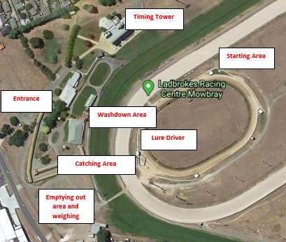

Launceston site map – facilities

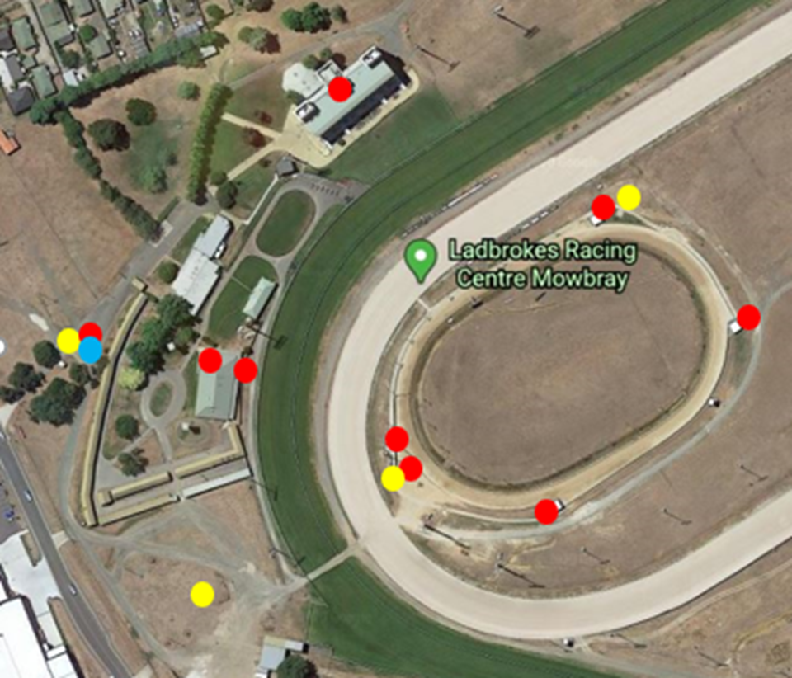
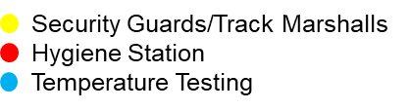
6.14 Booking of Greyhound Trials
Trainers are required to book trials by 5:00pm on Monday for Tuesday trials and by 5:00pm on Thursday for Friday trials and stipulate the distances over which they wish to trial.
Trainers, when booking their trial session, must nominate the name of all the licensed persons who will be attending the trials (themselves included).
A maximum of three greyhounds only will be permitted in any one trial.
One trainer and one catcher only will be permitted for a trial session unless more than one greyhound will run in the same trial, whereby the following schedule will be applied:
- Field trial – Three greyhounds – two handlers and two catchers.
A trainer can have additional licensed assistants in accordance with the following schedule:
- 7-12 greyhounds – 1 additional licensed person;
- 13-18 greyhounds – 2 additional licensed persons;
- 19-24 greyhounds – 3 additional licensed persons; and
- 25 or more greyhounds – 4 additional licensed persons.
Trials will be subject to a booking requirement which will be managed by the Launceston Greyhound Racing Club staff.
There will be no fees payable for trialling.

6.15 Frequency of Trials
Run-on trials will be held at the venue on Tuesday mornings commencing at 9.00am with normal trials on Friday nights commencing at 6.00pm and will be held over all distances up to 515 metres initially.

6.16 Arrival Time at Race Venue
Trainers must arrive at the venue in accordance with the following schedule:
- up to four greyhounds – 15 minutes prior to their booking time;
- up to 10 greyhounds – 25 minutes prior to their booking time;
- more than 10 greyhounds – 35 minutes prior to their booking time.
On arrival at the venue the trainer must make their way to the horse float car park area behind the stables.
From this area trainers may empty and weigh their greyhound while ensuring social distancing of a minimum of 1.5 metres. The kennel building will be open for access to the toilets and to weigh greyhounds only and must be departed from immediately. Once emptied and weighed, greyhounds are to be put back in the vehicle and the trainer (and assistant/s) remain in their vehicle.

6.17 Ready to Trial
When called, the trainer will move their vehicle across the harness track to the catching pen area to allow the catcher to alight from the vehicle. The trainer will then proceed directly to the start positions of their trial session.
The catcher is to remain in the vehicle and can only alight the vehicle at the catching pen area and then make their way to the catching pen.

6.18 Trialling
Initially trials will be conducted from the 515 boxes forward, in order of each starting point (as required by the Trainer).

6.19 After Trialling

Immediately after their last greyhound has trialled, the trainer is to drive to the catching pen and collect their greyhound/s and catcher/assistants.
The wash area in the vicinity of the 278 boxes is not to be used. Trainers may transport their greyhounds back to the car park area and utilise the wash bay at the back of the kennels to wash and water greyhounds. Trainers must vacate the venue immediately once they have appropriately taken care of the welfare of their greyhound/s.

- PROCEDURE REVIEW CYCLE
This Procedure is classified as operational and is to be approved, reviewed and endorsed by the Tasracing CEO on a regular and ongoing basis, or when there is a significant change to the external environment. The Procedure will be provided to the Tasracing’s Audit & Risk Committee for noting.

- REFERENCES
- Tasracing Working Safely in a COVID-19 Environment Procedure
- Tasracing COVID-19 Safety Plan
- Tasracing Risk Assessment
- Tasracing Code of Conduct Manual
- Tasracing Workplace Health and Safety Procedure
- Tasracing Privacy Management Framework
- Tasmanian Work Health and Safety Act 2012 (WHS Act)
- Tasmanian Work Health and Safety Regulations 2012 (WHS Regulations)
- SafeWork Australia
- WorkSafe Tasmania
- Tasmanian Government Department of Health
- Minimum Standards (Work Health and Safety Amendment Regulations 2020)
- Cleaning Procedure

- DOCUMENT CONTROL

Date | Version | Author | Approved by
18 May 2020 | 1.0 | IPM Consulting Services
19 May 2020 | 1.1 | Liam Swan
20 May 2020 | 1.2 | Ann Swain | CEO

