- PURPOSE
The Tasmanian government has a plan to ‘Rebuild a Stronger Tasmania’. As part of this plan, all workplaces are required to have a COVID-19 safety plan that complies with the minimum COVID-19 safety standards. The purpose of this Procedure is to outline the protocols that demonstrate our compliance with the Minimum Standards (Work Health and Safety Amendment Regulations 2020).
The Procedure demonstrates our ability to protect Tasracing’s workers and racing industry participants as we operate with new hygiene and safety protocols during the COVID-19 pandemic for the purpose of greyhound races at the venue.
Tasracing is committed to providing a healthy and safe working environment and has identified alternative ways to deliver its racing operational practices to limit the spread of COVID-19. It is imperative that we comply with the safety standards outlined in this Procedure to safeguard racing in Tasmania.
For the purpose of this Procedure:
“we / our” means Tasracing Workers, the racing industry participants, the Stewards and Racing Officials.
“workplace” means a place of work for Tasracing Workers and the racing venues, Ladbrokes Racing Centre (Launceston), Ladbrokes Park (Hobart) and Devonport Showgrounds (DAPS), where the race meetings are held.
“venue” means the Ladbrokes Racing Centre (Launceston), Ladbrokes Park (Hobart) and Devonport Showgrounds (DAPS) as applicable to the location of the race meeting.
The Australian Federal, State and Territory Governments have put restrictions in place to slow the spread of COVID-19. The National Cabinet have a 3-step plan to create a COVIDsafe society with new ways of living and working. This Procedure will be regularly reviewed and updated as these restrictions are varied and to reflect the recommendations by the Governments and Worksafe Tasmania.

- SCOPE
This Procedure applies to:
Tasracing: | Tasracing employees (including full-time, part-time, casual and fixed term employees), volunteers, contractors (security, Track Marshalls and suppliers to Tasracing) (collectively referred to as Tasracing Workers)
Racing Industry Participants | All industry participants and other persons that attend greyhound meetings at the venue.
Stewards | Stewards of the Office of Racing Integrity (ORI).
Racing Officials | Includes judges, vets, track workers, attendants, Club Committee members, club employees and volunteers and any other position deemed to be a Race Official by Tasracing or ORI.
General Public | Includes all members of the General Public attending the venue
- CORONAVIRUS
3.1 COVID-19
Coronaviruses are a large family of viruses that cause respiratory infections. These can range from the common cold to more serious diseases. Coronavirus is a disease caused by a new form of coronavirus. It was first reported in December 2019 in Wuhan City in China and the disease outbreak is named COVID-19.

3.2 Symptoms
Symptoms of COVID-19 include fever, coughing, sore throat and shortness of breath. If you have any of these symptoms do not attend your workplace or a race meeting.

3.3 Protect others and stop the spread
It is a requirement that all Tasracing Workers, Racing Industry Participants, Stewards and Racing Officials practice good hygiene, social distancing and understand when to self-isolate if you need to. These practices will slow down the spread of the virus.
Good hygiene means: | - wash your hands often with soap and water. This includes before and after eating and after going to the toilet;  - use alcohol-based hand sanitisers when you can’t use soap and water;  - avoid touching your eyes, nose and mouth at all times;  - maintain good hand, sneeze and cough hygiene;  - clean and disinfect surfaces you use often such as benchtops, barriers and doorknobs;  - clean and disinfect objects you use often such as mobile phones, keys, wallets and work passes; and  - increase the amount of fresh air by opening windows or utilising air conditioning.
Social distancing | The more space between you and others, the harder it is for the virus to spread. Social distancing in public means you keep 1.5 metres away from others wherever possible and avoid physical greetings such as handshakes.
Self-isolate | A person with COVID-19 or suspected to have the virus must enter mandatory isolation. You will need to isolate to prevent the spread of the virus to others at your home if it is suitable, hospital if you need hospital care or another location if needed as decided by the public health authority.

- RESPONSIBILITIES
Role | Responsibility
Chief Executive Officer | The CEO is responsible for:  - implementing this Procedure;  - monitoring the effectiveness of the Procedure (proactive risk management of determining the effectiveness of the control measures); and  - continual improvement of the Procedures.
Track Marshalls | The Track Marshall is responsible for:  - providing on-site education and ensuring compliance of this Procedure by all attendees at a race meeting  - monitoring and reporting compliance of the Procedure by all attendees at a race meeting  - reporting the effectiveness of the Procedure controls;  - recommending improvement opportunities to the CEO; and  - seeking continuous Procedure improvement for enhanced compliance.
Security | Security is responsible for ensuring the maximum attendance numbers stipulated in clause 5.1 are not exceeded and will monitor social distancing at the point of entry.
Tasracing Workers | Tasracing Workers must comply with this Procedure and assist the Track Marshalls and Officials in ensuring that all permitted attendees at a race meeting comply with this Procedure.  Tasracing Workers are responsible for identifying improvements to compliance controls and reporting them to the CEO.
Racing Officials | Racing Officials must comply with this Procedure and provide written recommendations for improvements for enhanced compliance controls to the CEO.
Racing Industry Participants | Racing Industry Participants have a responsibility to understand, observe and comply with this Procedure and related procedures, and to identify and report improvements to enhance compliance controls to the CEO.
General Public | Member of the General Public have a responsibility to understand, observe and comply with this Procedure and related procedures.
- GREYHOUND RACE MEETING REQUIREMENT
5.1 Executive Summary
Greyhound race meetings are to be conducted at the venue with no more than:
- Inside area - 1 person per 2 sqm up to a maximum 250 persons
- Outdoor area - 1 person per 2 sqm up to a maximum 500 persons
(N.B. These limits include all staff.)
In addition to these venue limits, the social distancing requirement of 1.5 metres also applies at all times.
Tasracing’s greyhound race meetings will be managed strictly in-line with this Procedure and WorkSafe Tasmanian’s Guidelines for COVID Safe Workplace operations.

- GREYHOUND RACE DAY PROTOCOLS

6.1 Before Leaving Home
Do not attend the race meeting if you feel ill or have any of the symptoms outlined in section 3.2.
If you identify with any of the below conditions, you MUST stay home and not attend any race meeting:
- you are suffering COVID-19 symptoms or are otherwise unwell:
- you are subject to self-isolation requirements imposed by the Government / Public health authority; or
- you have been in close contact with a person suspected or confirmed to have COVID-19.

6.2 People most at risk of COVID-19
People aged 70 years and over, people aged 65 years and over with chronic medical conditions, people with compromised immune systems, and Aboriginal and Torres Strait Islander people over the age of 50, are at greater risk of more serious illness if they are infected with COVID-19. Chronic medical conditions include but are not limited to diabetes, lung disease, heart disease, cancer and kidney failure. There is currently no cure or vaccine for COVID-19, or immunity in the community, so you must exercise a high degree of caution when deciding to attend a race meeting.
Tasracing strongly recommends that people most at risk continue to stay at home, avoid contact with others and carefully consider whether attending a race meeting (including accessing licensed kennels) will compromise their health. Should you attend a race meeting, Tasracing reminds you to practice good hygiene and social distancing measures to best support your health and wellbeing.

6.3 Venue Restrictions and Hygiene
In addition to the good hygiene requirements outlined in section 3.3, the following procedures will take place at venues for all greyhound race meetings:
- Food and/or drink may be available at the venue in line with the hospitality industry guidelines for the provision of food and drink;
- doors will be left permanently open where possible to allow throughway access without touching surfaces;
- disposable gloves will be provided by Tasracing to all permitted persons attending the race meeting to wear if they wish;
- hand sanitiser will be supplied at the entry to the venue, toilets, scales, starting boxes, kennels and catching pen area;
- all attendees will be required to wash/sanitise their hands thoroughly throughout the race meeting;
- all workstations will be wiped clean before use and after a race meeting in accordance with the cleaning procedure.

6.4 Race Venue Entry Protocols
Security will monitor the total number of persons present at a race meeting to ensure maximum attendance numbers as per clause 5.1 are not exceeded.

6.5 COVIDSafe App
Tasracing encourages all persons to play an important role in helping stop the spread of COVID-19 by downloading the COVIDSafe app. The app can be downloaded at the following link: https://www.health.gov.au/resources/apps-and-tools/covidsafe-app.

Downloading the app is something you can do to protect yourself, your family and the racing industry. The app helps expedite contact tracing and serves to benefit the racing industry in the event the app user tests positive for COVID-19.
If you do not wish to download the app or do not have a smartphone to download the app, Tasracing recommends that you maintain a travel log to perform a similar function.

6.6 Travel Log Requirements
The recommended minimum amount of travel details to be kept by anyone attending a race meeting (who do not have the COVIDSafe app) is as follows:

- date;
- name of person(s) making the journey;
- departure address; and
- location of all stops during the journey to the race meeting; including the name and address of any business visited (service station or takeaway food outlet etc).

6.7 Social Distancing
In accordance with section 3.3, you are required to comply with the strict social distancing requirements while attending a race meeting. A minimum distance of 1.5 m between any two personnel is required. If any person fails to adhere to this social distancing requirement, Security and Track Marshalls will have authority to direct a person to leave the venue.

6.8 Duties of Track Marshalls
Track Marshalls shall be present at every race meeting and will monitor all areas of the venue as required.
Track Marshalls will be responsible for ensuring all documented protocols in the Procedure are adhered to by all permitted persons attending the race meeting.
Track Marshalls may demand identification information and will be authorised to report breaches to the Stewards. They will be observing all persons attending the race meeting to ensure compliance with this Procedure.
Track Marshalls will pay particular attention to social distancing and all personnel must follow the direction of Track Marshalls in relation to social distancing.

6.9 Non-compliance
Any racing industry participant found to have breached a COVID-19 principle and/or protocol as contained within this Procedure will be reported to the Stewards for inquiry and will be subject to any penalty the Stewards deem appropriate. They will be escorted off the venue immediately.
Non-compliance of this Procedure shall be considered an offence under GAR 86(p) – “A person (including an official) shall be guilty of an offence if the person disobeys or fails to comply with the lawful order of a Steward or other person or body having official duties in relation to greyhound racing”.
For Tasracing Workers, incidents of non-compliance with this Procedure are considered to be serious and may result in disciplinary outcomes or termination of the contract (for contractor’s engagements).
Any members of the general public found to be in breach of the protocols will be reported to authorities and removed from the venue.

6.10 Venue Signage and Social Distance Markings
Tasracing will display clear instructions and reminders of these protocols at the venue. Floor and ground markings will be installed (where possible) to assist all personnel to adhere to social distancing protocols.
Track Marshalls will monitor adherence to floor or ground markings.

6.11 Wet Weather Gear
To minimise the spread of COVID-19, wet weather gear will not be made available at the venue. You are required to bring your own wet weather gear for your own personal use.

6.12 Prior to Arrival at Track
Tasracing encourages all persons to play an important role in helping stop the spread of COVID-19 by downloading the COVIDSafe app. The app can be downloaded at the following link: https://www.health.gov.au/resources/apps-and-tools/covidsafe-app.
Downloading the app is something you can do to protect yourself, your family and the racing industry. The app helps expedite contact tracing and serves to benefit the racing industry in the event the app user tests positive for COVID-19.
If you do not wish to download the app or do not have a smartphone to download the app, Tasracing recommends that you maintain a travel log to perform a similar function.
Any person who is in a high-risk group such as older people or people with underlying illnesses that make them more vulnerable to respiratory disease, including those with diabetes, chronic lung disease, kidney failure and people with suppressed immune systems, should not attend race meetings (including accessing licensed kennels).

6.13 Entry To Kennel Area

Entry to the kennel area will be restricted in accordance with Clause 5.1.

Participants are encouraged to utilise the hand sanitiser provided on both entry and exit to the kennels.

Entry and exit points to kennels to use different doors where applicable to enable social distancing.

Stewards and Vets to wear rubber gloves when kenneling, swabbing and during veterinary examinations.

Trainers are encouraged to leave all bedding outside prior to kennels opening and only brought in for each greyhound when kenneling.

All kennelling and pre-race procedures will revert back to the pre Covid-19 procedures, but with the requirement to ensure venue limits of 1 person per 2 square metre and social distancing is maintained.

Trainers are required to sanitise their hands on every occasion prior to placing their greyhound into the cage on the weighing scales.

Between races, kennel staff will monitor numbers to ensure the maximum number of persons is not exceeded.

6.15 Starting

Boxing of greyhounds will be done in 4 lines instead of 2 with 1.5 metres between lines. These lines will be 1-5, 3-7, 2-6, 4-8 giving 1.5 metres between each participant.

Participants are encouraged to utilise the hand sanitiser provided when leaving the starting area.

6.16 Catching Pen

Only the catchers involved in catching a greyhound participating in the race and officials are permitted in the catching pen area.

Participants must not congregate in the catching pen area between races.

Catchers are required to maintain 1.5 metre distancing prior to and during a race and to maintain 1.5 metre distancing as much as practical when catching their greyhound.

Once all greyhounds have been caught the catchers shall then leave the catching pen while maintaining a minimum of 1.5 metre distancing. No persons are to leave the catching pen until all greyhounds have been restrained.

Participants are encouraged to utilise the hand sanitiser provided when leaving the catching pen area.

Hobart Race Meeting Locations

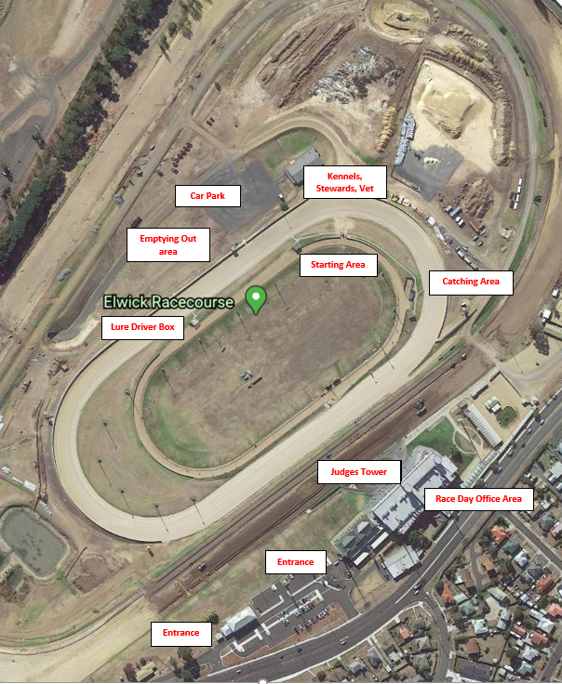

Hobart site map – facilities

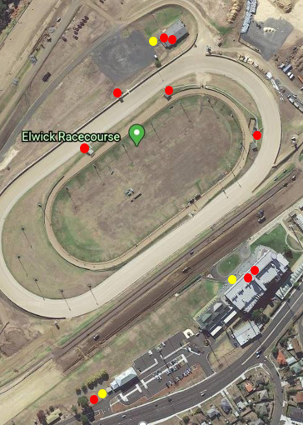

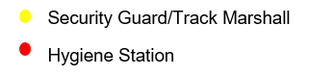

Launceston Race Meeting Locations

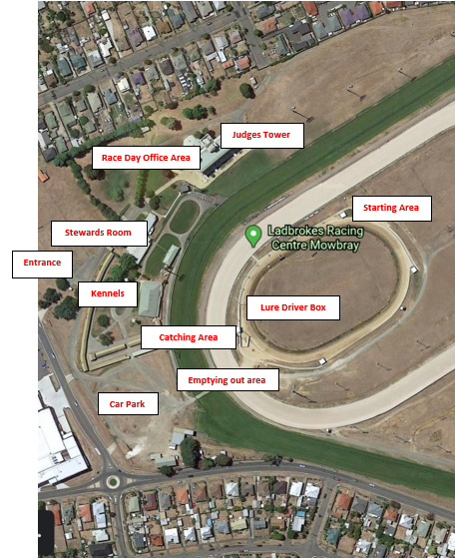

Launceston site map – facilities

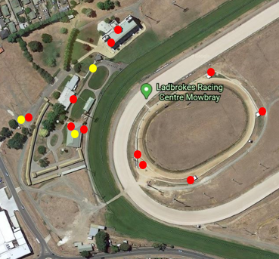

Devonport Race Meeting Locations

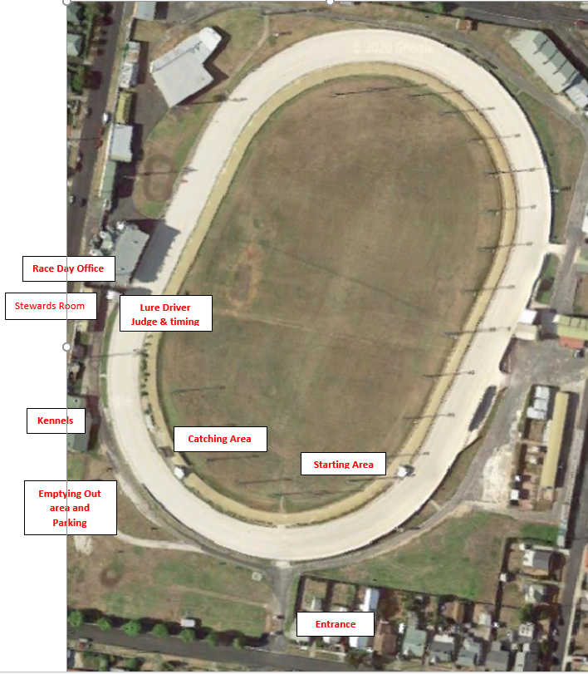

Devonport site map – facilities

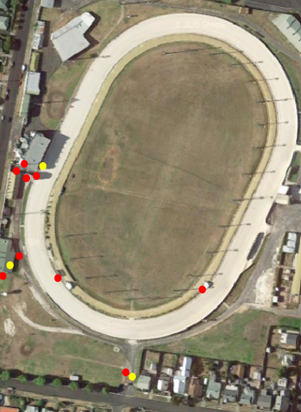

- PROCEDURE REVIEW CYCLE
This Procedure is classified as operational and is to be approved, reviewed and endorsed by the Tasracing CEO on a regular and ongoing basis, or when there is a significant change to the external environment. The Procedure will be provided to the Tasracing’s Audit & Risk Committee for noting.

- REFERENCES
- Tasracing Working Safely in a COVID-19 Environment Procedure
- Tasracing COVID-19 Safety Plan
- Tasracing Risk Assessment
- Tasracing Code of Conduct Manual
- Tasracing Workplace Health and Safety Procedure
- Tasracing Privacy Management Framework
- Tasmanian Work Health and Safety Act 2012 (WHS Act)
- Tasmanian Work Health and Safety Regulations 2012 (WHS Regulations)
- SafeWork Australia
- WorkSafe Tasmania
- Tasmanian Government Department of Health
- Minimum Standards (Work Health and Safety Amendment Regulations 2020)
- Cleaning Procedure

- DOCUMENT CONTROL

Date | Version | Author | Approved by
5 June 2020 | 1.0 | Liam Swan | CEO
16 June 2020 | 1.1 | Liam Swan | CEO
26 June 2020 | 1.2 | Liam Swan | CEO

