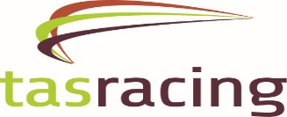

Expression of Interest – Lure Driver Hobart

Tasracing are seeking expressions of interest from individuals who are interested in being employed as a lure driver at Ladbrokes Park, Elwick.

It is expected you will be available for Thursday evening race meetings, Saturday morning and every second Wednesday evening for trial sessions.

Successful applicants will undergo in depth training and be required to gain approval from the Office of Racing Integrity Stewards to drive the lure under race conditions.

Please note you will be employed by Tasracing for all race meetings and by Hobart Greyhound Racing Club for all trial sessions.

Please forward your expression of interest or any queries by either email, telephone or in person to: -

Nathan Donaghy – Greyhound Coordinator – Tasracing
Ladbrokes Park Elwick, 6 Goodwood Road, Glenorchy TAS 7010
t: 6212 9360
m: 0448 901 596
n.donaghy@tasracing.com.au

